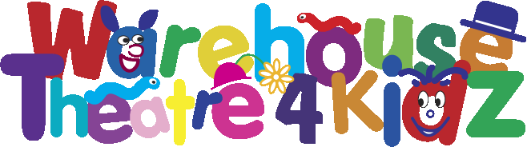
020 8680 4060
party menu
choice of
Hot Dog, Burger, Chicken Nuggets,
Fish Fingers, Pizza or Veggie Burger
& Chips

Ice Cream

Soft Drink

(free Tea & Coffee for adults)
dgdg
£5.50 per child
Parties must be minimum of 15 children
50% deposit required week in advance
Please bring your own Birthday cake Decorations not included
Please make sure you have booked your theatre tickets
before arranging your party with the CaféBar on 020 8680 4794
* Please note that our products may contain traces of nuts.

